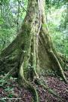
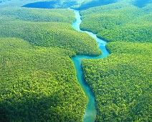
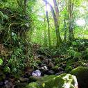
Tropical Rainforests (Tropische Regenwälder)
Video :David Attenborough

Watch the video and try to answer the questions. The answers are in order of the video. If you miss an answer just go on to the next one.

- What two things give the rainforest the greatest amount of life on earth?

- What is an emergent tree? (Kronendach reichender Baum)

- What is the climate like around emergent trees?

- How do leaves collect the most light in the canopy layer? (Die Baumschicht)

- Why is the canopy called the pasture of the jungle?

- There are no seasons in the jungle. When do the plants lose their leaves?

- Why do plants make a lot of nectar and fruit?

- Orchids and bromeliads are plants that grow on the trunks of the trees. How do they survive here? (die Orchideen und die Bromelien)

- Cross out the wrong words which are underlined. The next layer down has more/less light. The trees have few/many branches. Animals travel here by bus/swinging on lianes.(die Lianen)

- On the forest floor the trees have buttress roots (Die Stelzwurzeln).What do these do?

- How are the roots different to the roots of trees in our country?

- Cross out the wrong words which are underlined. There are few/many nutrients in the soil. Most are in the trees and leaf litter. The humid/dry air helps to speed up/slow down the decay of leaves. Roots which are deep down/close to the surface use these nutrients quickly. (Der Boden des Regenwaldes)

- What do termites like to eat?

- Why is the diversity of the jungle so great?

- How do young trees eventually reach the canopy?
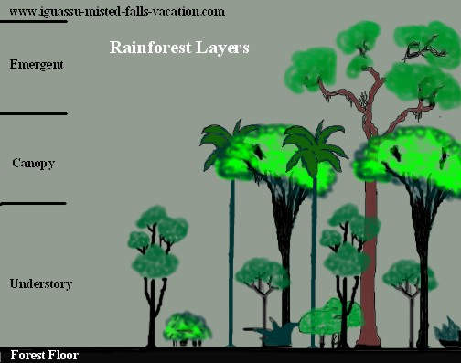
Oberer Stockwerk / Baumriesen
Baumschicht
Krautschicht

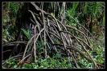
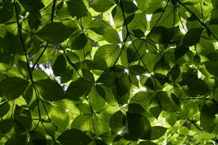

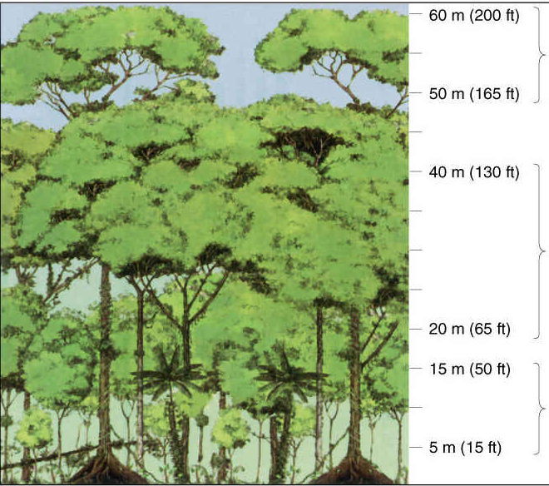

Die Strauchschicht Die Baumschicht Die Krautschicht

