Because…..

It rains a lot | 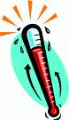  the temperatures are very high
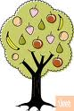  The temperatures are very high and it rains a lot therefore fruit grows. | There is a large amount of rain
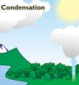  There is a lot of condensation | 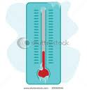  The temperatures are very low
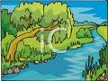  There is more water in the rivers | 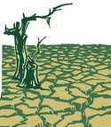  … there is no water in the rivers
It does not rain |   It has rained a lot
It does not rain a lot | 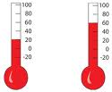  The temperature is…..degrees
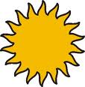  It is warm | 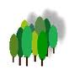  The forest is dry

