Ma chambre

La porte

|  |  |  |  |  |  |  |  |  |  |  |  |  |  |  |  |
| --- | --- | --- | --- | --- | --- | --- | --- | --- | --- | --- | --- | --- | --- | --- | --- |
|  |  |  |  |  |  |  |  |  |  |  |  |  |  |  |  |
|  |  |  |  |  |  |  |  |  |  |  |  |  |  |  |  |
|  |  |  |  |  |  |  |  |  |  |  |  |  |  |  |  |
|  |  |  |  |  |  |  |  |  |  |  |  |  |  |  |  |
|  |  |  |  |  |  |  |  |  |  |  |  |  |  |  |  |
|  |  |  |  |  |  |  |  |  |  |  |  |  |  |  |  |
|  |  |  |  |  |  |  |  |  |  |  |  |  |  |  |  |
|  |  |  |  |  |  |  |  |  |  |  |  |  |  |  |  |
|  |  |  |  |  |  |  |  |  |  |  |  |  |  |  |  |
|  |  |  |  |  |  |  |  |  |  |  |  |  |  |  |  |
|  |  |  |  |  |  |  |  |  |  |  |  |  |  |  |  |
|  |  |  |  |  |  |  |  |  |  |  |  |  |  |  |  |
|  |  |  |  |  |  |  |  |  |  |  |  |  |  |  |  |
|  |  |  |  |  |  |  |  |  |  |  |  |  |  |  |  |
|  |  |  |  |  |  |  |  |  |  |  |  |  |  |  |  |
|  |  |  |  |  |  |  |  |  |  |  |  |  |  |  |  |

0 20 40 60 80 100 120 140 160 180 200 220 240 260 280 300 cm

La fenêtre

m²

**Chaque carré est 20cm Le ratio = 1 : 20 1cm =20cm**

1. Ma chambre fait ………….mètres de long et ……….mètres de large
2. La superficie est …………mètres ² (on doit mutiplier les mètres de long par les mètres de large)
3. Vous devez dessiner le mobilier . Par exemple le lit est dessiné sur le papier quadrillé. Vous devez dessiner tous les meubles (le lit, le bureau , la bibilothèque etc)
4. Maintenant vous devez couper les meubles et vous devez coller les meubles sur le plan de la chambre.

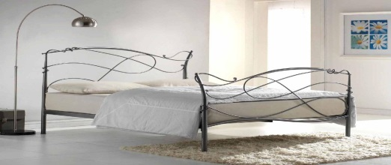 le lit 200cm X 100cm

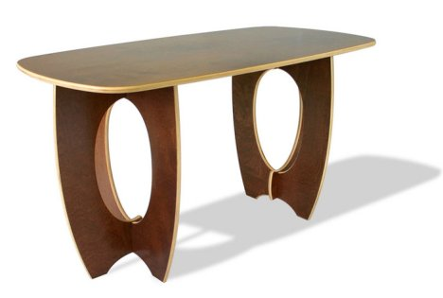

Le bureau 120cm X 60 cm

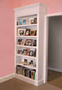La bibliothèque 100cm X 30cm

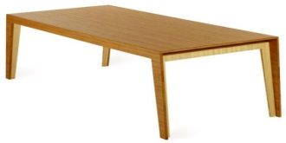La table 80 X 60cm

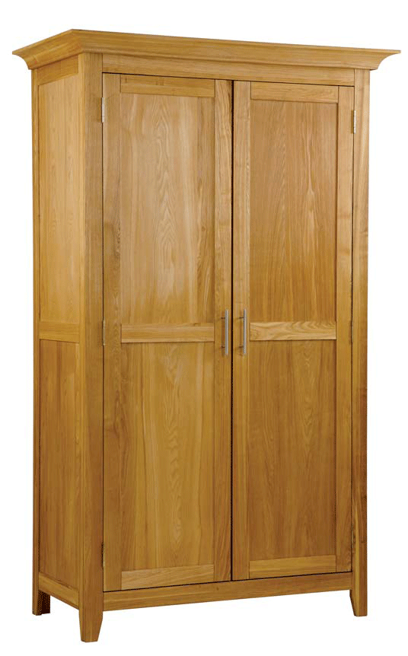

Le placard 60cm X 50cm

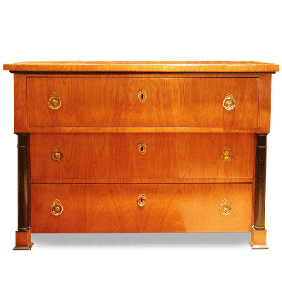

La commode 100 X 50 Cm

**Dessinez les meubles ici !!**

|  |  |  |  |  |  |  |  |  |  |  |  |  |  |  |  |
| --- | --- | --- | --- | --- | --- | --- | --- | --- | --- | --- | --- | --- | --- | --- | --- |
|  |  |  |  |  |  |  |  |  |  |  |  |  |  |  |  |
|  |  |  |  |  |  |  |  |  |  |  |  |  |  |  |  |
|  |  |  |  |  |  |  |  |  |  |  |  |  |  |  |  |
|  |  |  |  |  |  |  |  |  |  |  |  |  |  |  |  |
|  |  |  |  |  |  |  |  |  |  |  |  |  |  |  |  |
|  |  |  |  |  |  |  |  |  |  |  |  |  |  |  |  |
|  |  |  |  |  |  |  |  |  |  |  |  |  |  |  |  |
|  |  |  |  |  |  |  |  |  |  |  |  |  |  |  |  |
|  |  |  |  |  |  |  |  |  |  |  |  |  |  |  |  |
|  |  |  |  |  |  |  |  |  |  |  |  |  |  |  |  |
|  |  |  |  |  |  |  |  |  |  |  |  |  |  |  |  |
|  |  |  |  |  |  |  |  |  |  |  |  |  |  |  |  |
|  |  |  |  | **Le lit** |  |  |  |  |  |  |  |  |  |  |  |
|  |  |  |  |  |  |  |  |  |  |  |  |  |  |  |  |
|  |  |  |  |  |  |  |  |  |  |  |  |  |  |  |  |
|  |  |  |  |  |  |  |  |  |  |  |  |  |  |  |  |

0 20 40 60 80 100 120 140 160 180 200 220 240 260 280 300 Coupez les meubles  Collez les meubles sur le plan de la chambre[](http://images.google.co.uk/imgres?imgurl=http://www.lfstationery.com/3482/glue-stick-series/glue-stick-series-LF-GL-0910A.jpg&imgrefurl=http://www.lfstationery.com/&h=359&w=400&sz=103&hl=en&start=6&um=1&tbnid=sYz_qZP_yYEVWM:&tbnh=111&tbnw=124&prev=/images?q%3Dglue%2Bstick%26um%3D1%26hl%3Den%26safe%3Dactive%26sa%3DG)