L’année 7/ La sixième

La Géographie : Où sommes-nous dans le monde ?

Les cartes

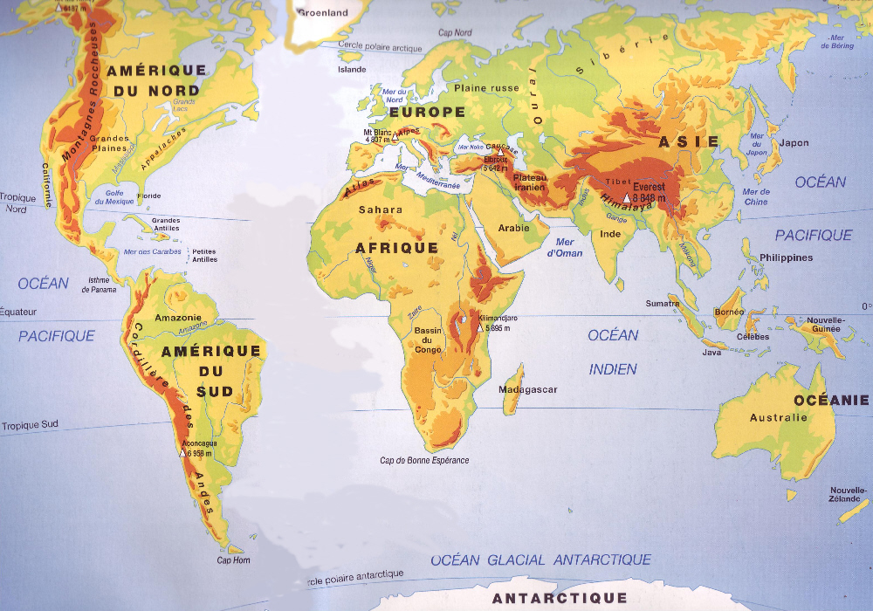

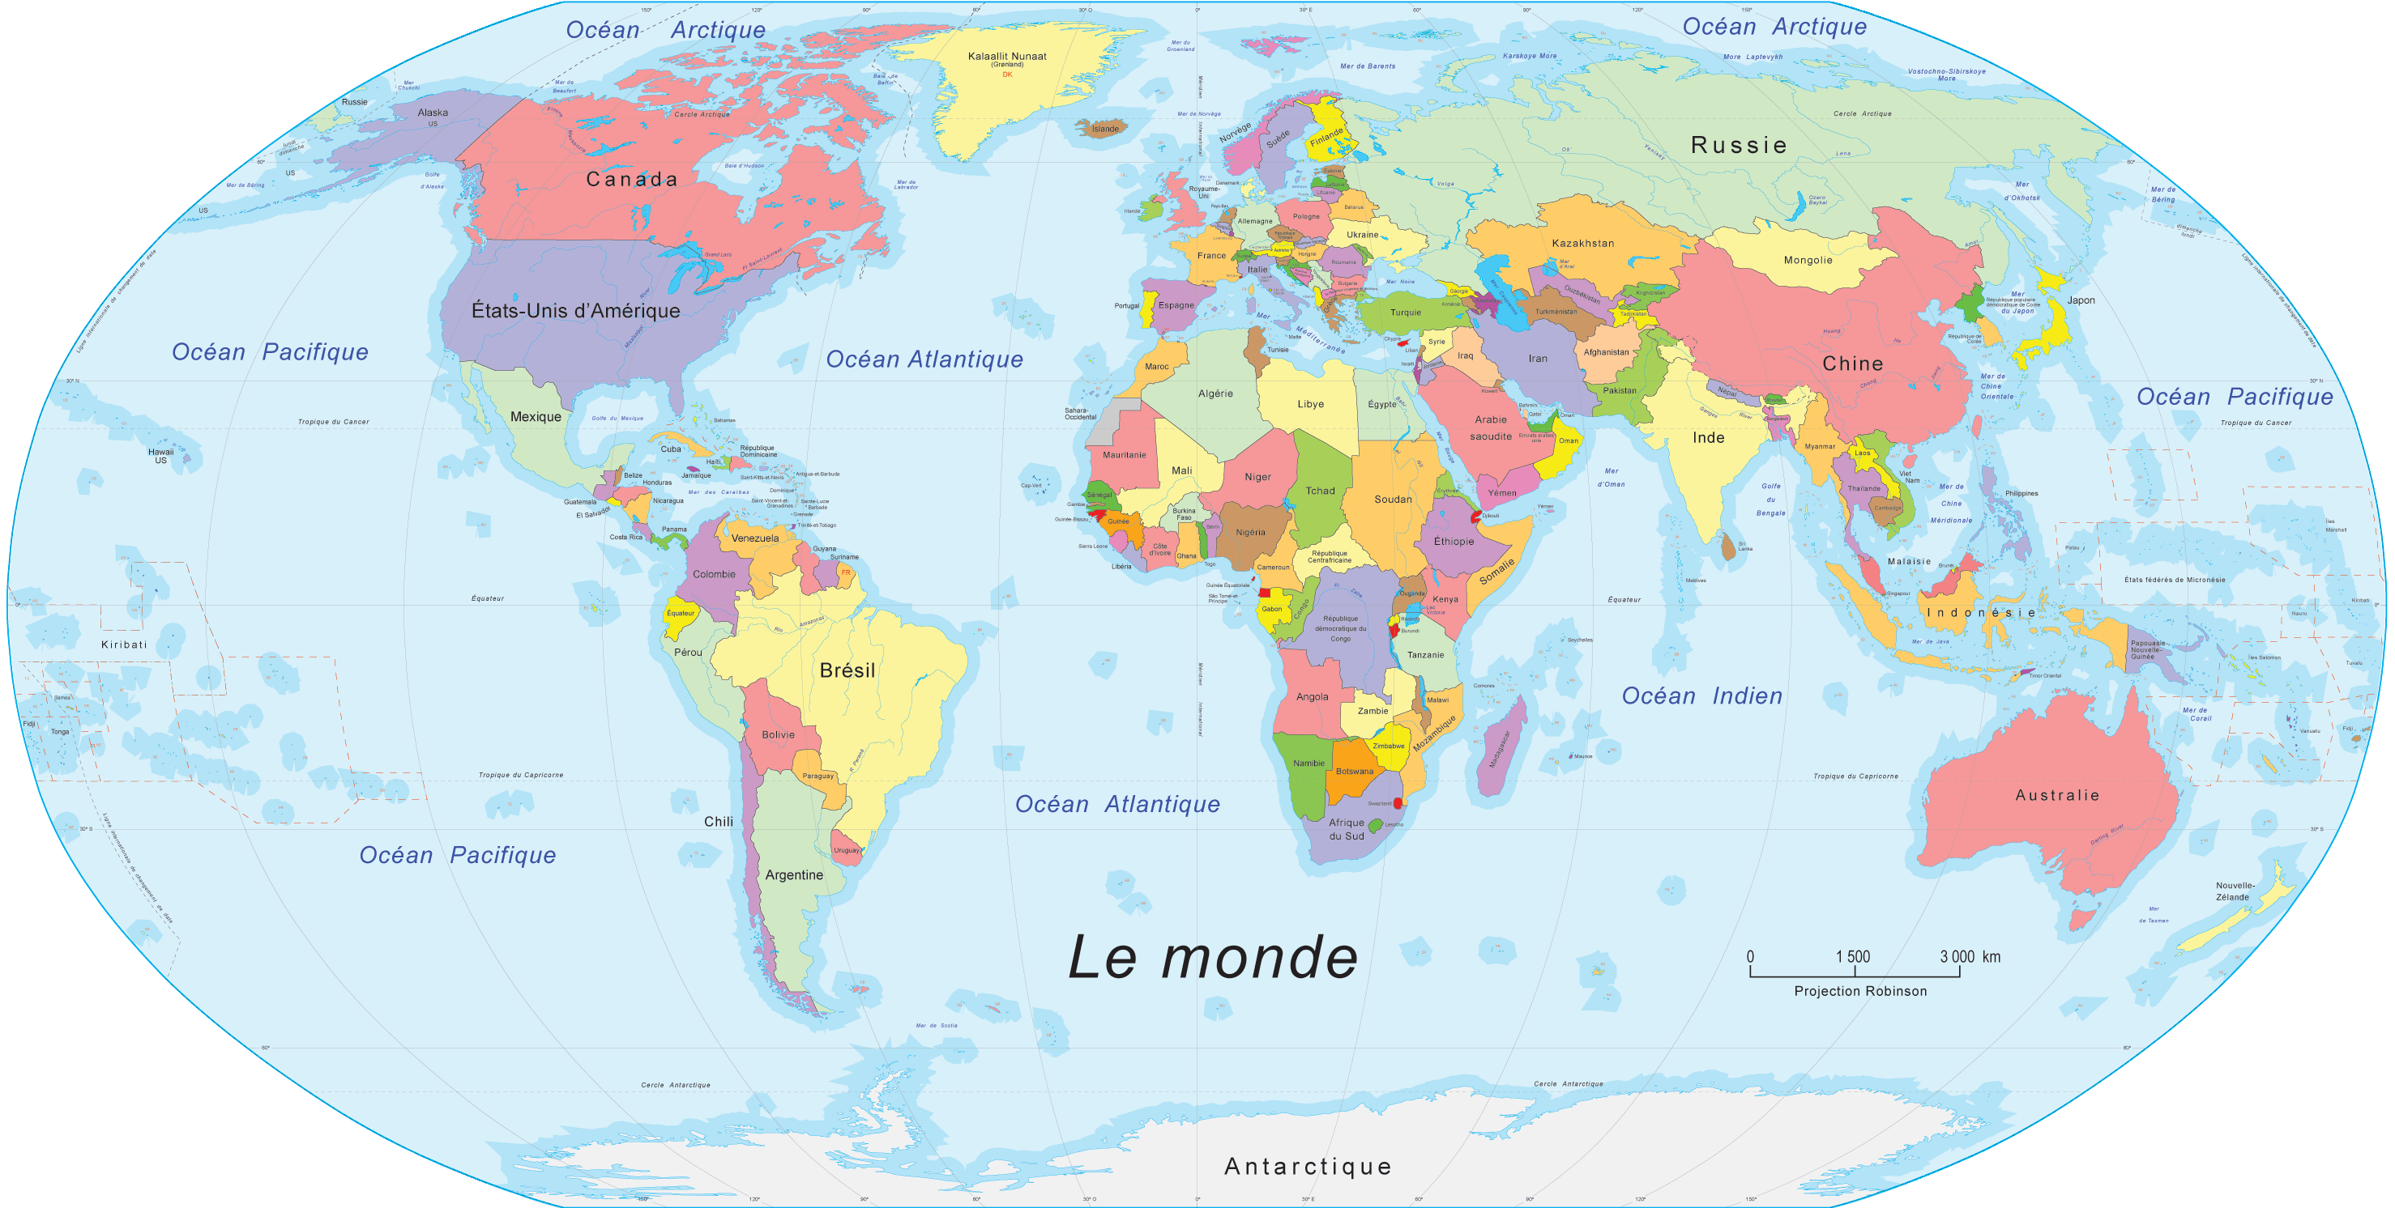

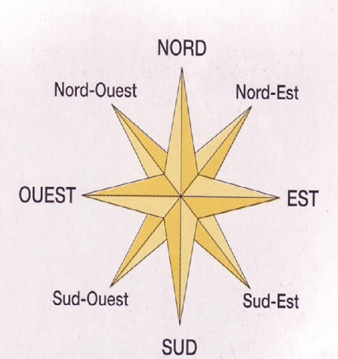

© Judith Woodfield 2014

|  |  |  |  |
| --- | --- | --- | --- |
| Page |  | Page |  |
| 3  4  5.  6  7.  8 -9  10  11-14  16  16  17  18-19  20  21  22  23  24-25  26  27  28-29  30  31  32-34  35-37  38-40  41  42  43  44-45  46-51  52 | Introduction to Year 7  When , where and what to bring  International buzz words  How to help learn language  WILF special agent for Geography  Language levels  Language list  Skills  Classroom phrases  Les ordinateurs  Website information  Phrases for classroom discussions  Où sommes nous dans le monde  Geography pictures  Map vocabulary  Longitude and latitude  Longitude and latitude powerpoint  Symbols or signs  Bingo  OS Symbols  Spot the difference  Word frame  Powerpoint about grid references  Drawing a bedroom to scale  Scale powerpoint  Contour sheet  Cross-section diagram  Cross-section task  Relief powerpoint  A journey using an OS map  Points chart |  |  |

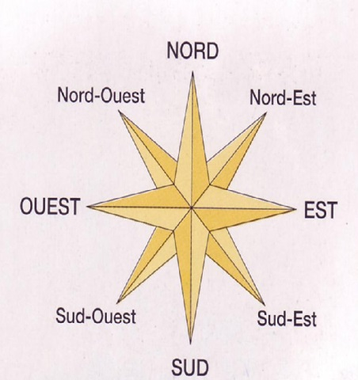

©

Stick your photo onto here

***Your name:………………………………………………***

***What does it mean to be in the immersion group?***

In your Geography lessons your teacher will speak French to you. The lessons will start with some simple French and will gradually build up during the year. You will find the first half term a little tricky and you may feel like saying **“ It would be much easier if it was in English !”** However you will notice that by Christmas you will suddenly understand most of what is being said in the classroom. You will also be contributing more and more French in the lessons. The lessons will use a lot of pictures and activities which will help you to learn Geography, just as well as students learning it in English. The course has been designed in a slightly different order to the topics covered by other classes. This is to help build up the language you need to be able to complete some of the assessments to the best of your ability.

**What do I do if I find it difficult?You must always let your teacher know if you are finding things difficult. j0078748**

There are other people who can help you too, the French Assistant, other students who study French and your parents.

Remember there are some things you can do to help yourself. In this booklet you will find some ideas

for different ways to learn your vocabulary (this is *really* important). You will also find a list of useful

web-sites. Try to use them to help you.

|  |  |  |
| --- | --- | --- |
| On joining Year 7 I am at Excellence  Secure, Developing, Emerging | in Geography | in French |
| Assessment 1 Mapwork | in Geography | in French |
| Assessment 2 Rainforest poster | in Geography | in French |
| Assessment 3 Rainforest essay | in Geography | in French |

|  |  |
| --- | --- |
| j0237464 | j0215356 |
|  |  |
|  |  |
|  |  |
|  |  |
|  |  |



Experiment with these different ways of learning vocabulary suggested by other students ……..Your test scores will go up!

* Copy, look, cover, write, check.
* Get Mum, Dad or a friend to test you.
* Re-write the list over and over again.
* Teach the words to a member of your family.
* Work on an ever-reducing list until you know them all.
* Set the words or phrases to music eg a rap , chant, play the piano.
* Make a set of picture and word cards, place face down on the table and play pairs, matching them up.
* Write key words on post-its and stick them around your room or in the kitchen in a prominent position.
* Record the words in English and in the target language and listen to them last thing at night.
* In your lists use different colours for the target language and English equivalents.

e Use a highlighter pen.

* Try to recognise similar words, opposites and words of a group eg animals.
* Do a little revision often eg ten minutes twice a day.
* Learn the gender of nouns eg masculine or feminine (ie le/la,un/une in French
* Can you add more ways of learning vocabulary to this list
* pe07264_

Où est WILF ? Qui est WILF ?

pe03752_

WILF

What I am Looking for

International National Curriculum

**Emerging “WILF**”

*This agent does not record many glossary words. She/he needs to follow someone all the time. This agent rarely investigates places away from her local area. However she/he does bring some knowledge about the world to help describe what places are like. The agent knows what she/he likes about the world but rarely does anything to help it .This agent needs instructions to follow and has not begun to master many skills yet. She/he can recognise some things formed by physical processes and some formed by humans. She/he knows when she/he is walking up a hill and when she/he is in a town. This agent has a low buzz word rating and will not be able to speak to other agents in French speaking countries or English speaking countries in the same geographical code.*

*bd04935_*

**bd06986_**

**Emerging “WILF”**

*This agent has begun to look at things in more detail. She/he is beginning to learn about the things that help to shape the physical landscape and human environment. This agent is starting to use some of the skills that are needed to find out this information. She/he has also begun to ask other people what they think about things in order to reach conclusions. This agent has really begun to look for information about the planet. The agent is beginning to use buzz words to communicate. The agent has started to understand the need for looking after the environment so that she/he can blend in with it.*

**Developing “WILF” Local assignments**

*This agent is fine when she/he is given a set of instructions to follow. She/he uses a range of skills and both primary and secondary evidence. From this the agent is able to put together reasonable answers. The agent can compare the information with previous assignments. This agent is really interested in the differences between places. She/he uses buzz words at least once in every mission. This agent is trying hard to become a good citizen by looking after the environment and understanding the needs of others.*

**Developing “WILF” Regional assignments**

*This agent is now able to operate outside the local area and can describe many landscapes and the views of others. This agent can use his/ her information to understand places that she/he has never visited before. The agent can do this because she/he has collected a lot of evidence. The agent uses a lot of buzz words all the time and can communicate easily. Once in a place this agent can identify questions that need asking. She/he knows what to investigate. The agent can use a wide range of skills and both primary and secondary evidence to answer questions. These skills are suggested to the agent before she/he investigates a question. The agent is becoming more* *environmentally friendly and really is making an effort to look after people and the environment in order to leave few harmful traces of her/his activity behind.*

**Secure “WILF” National assignments**

*You can put this agent anywhere in this country or and she/he will be able to explain what is happening to both the physical and human landscape. She/he is able to understand the different ways of managing the environment because she/he has blended in so well and has left small ecological footprints. This agent will be able to choose questions to investigate and will be able to select her/his own skills. You can guarantee that this agent will not only use buzz words at every opportunity but will also present her/his findings using a range of techniques. Her/his findings will always make sense, will explain bias and the views of others and will always have evidence to back them up.*

**Secure “WILF” International assignments**

*This agent is a first rate planner. The agent really knows how to plan an investigation. This means that you can rely on her/him to complete a task and end up with conclusions that really are based on all the evidence. The evidence is always well presented and uses a lot of buzz words. You can put this agent anywhere in the world and she/he will be able to explain what is happening to both the physical , human and environmental landscape. She/he really is beginning to understand that different solutions are needed in different parts of the world. The problems that the agent solves will have good conclusions and will analyse bias and the views of others.*

**Excellence “WILF” Global Planner**

*This agent is a first rate planner. Using many buzz words the agent can go anywhere in the world and will be able to explain not only the physical and human landscape but also how these landscapes change. The agent knows that actions on one place will affect others, so she/he is very careful to look at the consequences for sustainable living. The conclusions presented are always extremely thoughtful and backed up by a lot of evidence. This care means that she/he is careful about the impact she/he has as an individual. Individual actions are very important. This agent has the ability to think globally and act locally. The arguments presented as conclusions to problems are comprehensive and conclusive, involving an analysis of people’s views and bias.*

**Excellence “WILF”** **Global Citizen**

*This agent can always be relied upon. The agent always manages to gather together evidence from all around the world to make sense of the planet. This agent knows how long things take to happen and really understands how complex solutions can be. The agent knows that solutions may be different in different parts of the world. This agent knows that she must think globally and act locally as an individual. The evidence that the agent gathers is always excellent. This agent goes above and beyond the call of duty to try to answer questions and discover more about the planet. You may find this agent very difficult to talk to unless you can master all the buzz words. She/he does use the word sustainable and globalisation rather often. She /he can solve any problem presented to him/her and the conclusions are always the result of brilliant analysis*

**

*Progress through the levels:*

As a Year 7 Modern Languages pupil you can

|  |  |  |  |  |
| --- | --- | --- | --- | --- |
|  | Emerging | Emerging | Developing | Developing |
|  |  |  |  |  |
| **1**  Listening and Responding  pe03324a | * Understand instructions, questions and short phrases with the help of repetition, mime or pictures | * Understand a range of phrases, sentences & instructions in language already met, with some repetition. * Respond, using words or actions | * Understand with repetition a series of phrases eg Using known language, short messages, conversations, instructions spoken at near normal speed. * Note main points and details | * Understand longer passages using familiar language in simple sentences from one topic. * Some repetition needed |
| **2**  Speaking  pe03323a | * Use single words/short phrases when speaking * Need repetition to practise correct pronunciation * Need some picture clues to help | * Use short set phrases/sentences * Ask for permission or help in the classroom * Say things clearly but still need pronunciation practice | * Take part in short conversations of 2/3 exchanges with prompts. * Use mostly learnt language * Change a few words | * Take part in a short conversation of ¾ exchanges using prompts * Use grammar to adapt some words and phrases |
| **3**  Reading and Responding  an00790_ | * Understand clearly written single words, often with the help of a picture | * Understand short words and phrases seen before * Read aloud familiar words and phrases * Look up the meaning of new words in book /glossary | * Understand short printed texts containing familiar language. * Note main points * Use a dictionary/glossary * Choose something to read on your own | * Understand short, printed and hand-written texts * Note main points and some details * Read alone using a dictionary/glossary or working out what words mean |
| **4**  Writing  hh01633_ | * Copy words you know correctly * Label pictures and choose the right word to fill in gaps in short sentences | * Copy short phrases you know correctly * Spell words from memory usually well enough to be understood | * Write with support 2-3 sentences on familiar topics * Express likes/dislikes * Write short phrases from memory * Use understandable spelling | * Write a paragraph of ¾ sentences, using memorised language * Begin to use grammar to add/change single words /phrases * Use a dictionary to check |

As a Year 8/9 Modern Languages pupil you can also reach the following levels

|  |  |  |  |
| --- | --- | --- | --- |
|  | Secure | Secure | Excellence |
| **1**  Listening and Responding  pe03324a | * Understand familiar language from   several topic areas ar near normal speed.   * Understand when present and past or   future events are described | * Understand familiar language in new situations covering past,present and future events with little repetition at normal speed eg story or description of an event | Understand passages which contain longer sentences and some new language,rarely needing repetition eg news items from TV/Radio |
| **2**  Speaking  pe03323a | * Take part in a short conversation   using present and past or future tenses.   * Give and ask for information and opinions | * Use the past,present and future tenses. * Use grammar to build your own phrases in new contexts * Make yourself understood fairly easily | * Take the lead in and develop a conversation on things of personal and topical interest * Adapt language to say things in different ways * Sound like a native speaker |
| **3**  Reading  and Responding  an00790_ | * Understand on your own a variety of texts   eg leaflets, articles with present and past or future events in them | * Understand a variety of texts with past and present and future tenses using familiar language in new situations * Scan a selection of written material and choose something which interests you to read on your own * Use clues more confidently to work out meaning | * Understand imaginative and factual material containing some language not met before * Use language met in reading materials in your s/w * Use reference materials |
| **4**  Writing  hh01633_ | * Write a short piece of simple sentences. * Refer to past experiences or future plans   as well as things you do every day | * Write in paragraphs, referring to past,present and future events * Use knowledge of grammar to make up new sentences | * Write on real and imaginary subjects * Link sentences and structure ideas * Redraft your work to improve quality |

***Developing your agent language skills.***

You will need to speak Geography buzz words in English and French…the more the better.

Record important words here and in your vocab books. These words will help you to decode information.

|  |  |
| --- | --- |
| Glossary Words | Meanings |
|  |  |
|  |  |
|  |  |
|  |  |
|  |  |
|  |  |
|  |  |
|  |  |
|  |  |
|  |  |
|  |  |
|  |  |
|  |  |
|  |  |
|  |  |
|  |  |
|  |  |
|  |  |
|  |  |
|  |  |
| © |  |

***Skills***

You will find that the best evidence is the evidence that you collect yourself primary evidence. Geographers often call this type of evidence fieldwork.

Year 7 skills

|  |  |  |  |  |  |  |  |  |  |  |  |  |  |  |
| --- | --- | --- | --- | --- | --- | --- | --- | --- | --- | --- | --- | --- | --- | --- |
| Type of skill  wb01637_ | Specific skill | Date completed | Pupil assessment | | | P=poor,  Av=average  G=good  E= excellent | | | Teacher assessment | | | P=poor,  Av=average  G=good  E= excellent | | |
| P  1 | 2 | Av  3 | | G  4 | E  5 | P  1 | 2 | Av  3 | | G  4 | E  5 |
| Survey | People  **Les gens** |  |  |  |  | |  |  |  |  |  | |  |  |
| bd05558_ | Questionnaires  **Les questionnaires**  s |  |  |  |  | |  |  |  |  |  | |  |  |
| bd19902_ | Interviewing  **L’interviewer** |  |  |  |  | |  |  |  |  |  | |  |  |
| bd06496_ | E mail  Questions  **E mail** |  |  |  |  | |  |  |  |  |  | |  |  |
| Landscape  E | Sketch map  **Une carte** |  |  |  |  | |  |  |  |  |  | |  |  |
| Type of skill  wb01637_ | Specific skill | Date completed | Pupil |  |  | |  |  | Teacher |  |  | |  |  |

Secondary evidence is research that other people have collected and /or presented

***Year 7 skills***

|  |  |  |  |  |  |  |  |  |  |  |  |  |  |  |
| --- | --- | --- | --- | --- | --- | --- | --- | --- | --- | --- | --- | --- | --- | --- |
| Type of skill  wb01637_ | Specific skill | Date completed | Pupil assessment | | | P=poor,  Av=average  G=good  E= excellent | | | Teacher assessment | | | P=poor,  Av=average  G=good  E= excellent | | |
| P  1 | 2 | Av  3 | | G  4 | E  5 | P  1 | 2 | Av  3 | | G  4 | E  5 |
| Collection of  Secondary Evidence | Using index in atlas  **L’atlas** |  |  |  |  | |  |  |  |  |  | |  |  |
| bd07214_ | Using a globe  **Le globe**  S |  |  |  |  | |  |  |  |  |  | |  |  |
| hh01296_ | Use of photographs  **photographies** |  |  |  |  | |  |  |  |  |  | |  |  |
| j0090779pe01482_ | Use of maps  **La carte** |  |  |  |  | |  |  |  |  |  | |  |  |
|  | 4 figure grid references  **une coordonnée** |  |  |  |  | |  |  |  |  |  | |  |  |
| Maps | 6 figure grid references  **une grille de**  **reference** |  |  |  |  | |  |  |  |  |  | |  |  |
| **Le relief** | Identifying relief and landscape features  **Le relief** |  |  |  |  | |  |  |  |  |  | |  | © |

|  |  |  |  |  |  |  |  |  |  |  |  |  |  |  |
| --- | --- | --- | --- | --- | --- | --- | --- | --- | --- | --- | --- | --- | --- | --- |
| Type of skill  wb01637_ | Specific skill | Date completed | Pupil assessment | | | P=poor,  Av=average  G=good  E= excellent | | | Teacher assessment | | | P=poor,  Av=average  G=good  E= excellent | | |
| P  1 | 2 | Av  3 | | G  4 | E  5 | P  1 | 2 | Av  3 | | G  4 | E  5 |
| Collection of  Secondary Evidence | Using longitude and latitude  **La longitude et la latitude** |  |  |  |  | |  |  |  |  |  | |  |  |
| pe01482_ | Using maps to make a decision  **Utilise rune carte pour predre une décision**  S |  |  |  |  | |  |  |  |  |  | |  |  |
| pe01755_ | Measuring distance with a scale.  **Une échelle** |  |  |  |  | |  |  |  |  |  | |  |  |
| tn00231_ | Identifying direction  **Une direction** |  |  |  |  | |  |  |  |  |  | |  |  |
| Research | Use of library  **La bibliothèque** |  |  |  |  | |  |  |  |  |  | |  |  |
| bs01108_  E | Use of Internet  **L’Internet** |  |  |  |  | |  |  |  |  |  | |  |  |
| Type of skill  wb01637_ | Specific skill | Date completed | Pupil |  |  | |  |  | Teacher |  |  | |  |  |
|  |  |  | P  1 | 2 | Av  3 | | G  4 | E  5 | P  1 | 2 | Av  3 | | G  4 | E  5 |
| Recording | Results table  **La table de résultats reltats rerésultats** |  |  |  |  | |  |  |  |  |  | |  |  |
|  | Map  **Une carte** |  |  |  |  | |  |  |  |  |  | |  |  |
|  | Word processed or written notes  **Les notes** |  |  |  |  | |  |  |  |  |  | |  |  |
|  | Spreadsheet  **Le tableur**  T |  |  |  |  | |  |  |  |  |  | |  |  |
| Type of skill  wb01637_ | Specific skill | Date completed | Pupil assessment | | | P=poor,  Av=average  G=good  E= excellent | | | Teacher assessment | | | P=poor,  Av=average  G=good  E= excellent | | |
| P  1 | 2 | Av  3 | | G  4 | E  5 | P  1 | 2 | Av  3 | | G  4 | E  5 |
| Presentation | Bar chart  **Le graph en bâtons** |  |  |  |  | |  |  |  |  |  | |  |  |
|  | Histogram  **Un histogramme**  S |  |  |  |  | |  |  |  |  |  | |  |  |
| bs01177_ | Pie chart  **Le camembert** |  |  |  |  | |  |  |  |  |  | |  |  |
|  | Sketch map  **La carte** |  |  |  |  | |  |  |  |  |  | |  |  |
| bd06887_ | plan  **le plan** |  |  |  |  | |  |  |  |  |  | |  |  |
|  | Spider diagram  **Un diagramme en étoile** |  |  |  |  | |  |  |  |  |  | |  |  |
| E | Powerpoint presentation  **Une presentation Powerpoint** |  |  |  |  | |  |  |  |  |  | |  |  |
| **L’affiche** | Leaflet or  Poster  **Le dépliant** |  |  |  |  | |  |  |  |  |  | |  |  |

French Language in the Classroom

**Try really hard to use these phrases in your French & Geography lessons!**

**You could earn yourself lots of commendations!**

|  |  |
| --- | --- |
| She is absent  He is absent | Elle est absente  Il est absent |
| She is on holiday  He is on holiday | Elle est en vacances  Il est en vacances |
| I have forgotten my book | J’ai oublié mon livre |
| How do you say …? | Comment dit-on …… |
| How do you spell….? | Comment écrit-on ….. |
| I am sorry | Je suis désolé(e) |
| Can I speak English? | Est-ce que je peux parler anglais? |
| Me too! | Moi aussi! |
| I agree! | Je suis d’accord |
| I disagree! | **Je ne suis pas d’accord** |
| Again! | Encore! |
| What is the date? | Quelle est la date aujourd’hui? |
| **And you!** | Et toi! |
| I do not understand! | Je ne comprends pas |
| What is the title? | Quel est le titre? |
| See you tomorrow! | A demain! |
| Have a nice weekend! | Bon week-end! |
| **I am ready** | J’ai fini |
| Sorry I am late | Je suis désolé(e) – je suis en retard |
| I need … | J’ai besoin .. |
| I don’t know | Je ne sais pas |
| Can I have some paper? | Est-ce que je peux avoir du papier? |
| Can we work in a group of three? | Est-ce qu’on peut travailler en groupe de trois? |
| Thank you | Merci (de rien) |
| Can we work with a partner? | Est-ce qu’on peut travailler avec un partenaire |
| Je n’ai pas un crayon | I don’t have a pencil |
| Je n’ai pas un stylo | I don’t have a pen |

j0233207le clavierj0205582

**Les ordinateurs**

un ordinateur

j0195870l’imprimante les touches j0237408le moniteur  la souris

un e mail

L’Internet

Un site web

j0237162les écouteurs, le micro

 la barre d’espacement

Return key is la touche de retour Capital lock is la touche de majuscule

Screen is l’écran

**To put accents into word processed work :**

Either go to **insert** then **symbol** and then choose your symbol from the chart eg **è** or use the keyboard as follows:

**Les accents**

Pour faire des accents

* **mettez Num Lock**
* **appuyez sur Alt et en même temps, tapez sur ……….**

**0233 – é 0232 – è 0234 – ê 0235 – ë 0201 – É 0202 – Ê**

**0224 – à 0226 – â**

**0249 – ù 0251 – û**

**0244 – ô**

**0231 – ç 0199 - Ç**

**0238 – î 0239 – ï**

©

**Useful Internet Addresses for French/Geography**

Try using some of these web-sites to work independently:

[www.quia.com](http://www.quia.com) – vocabulary & grammar activities

[www.zut.org.uk](http://www.zut.org.uk) – vocabulary & grammar activities

[www.zipzapfrance.com](http://www.zipzapfrance.com) – interactive activities

[www.learn.co.uk](http://www.learn.co.uk) – a variety of exercises

[www.bonjour.org.uk](http://www.bonjour.org.uk) – fun grammar & vocabulary activities

[www.4learningco.uk/apps/homework/index.jsp](http://www.4learningco.uk/apps/homework/index.jsp) – help with your homework

Geography mapwork sites

 A great website for practising mapwork skills

<http://neroucheffmichel.ozt4u.net/html/geographie.htm> a French site with lots of interactive games and activities to do with maps and countries

<http://nte-serveur.univ-lyon1.fr/geosciences/geometrie/Cours_carto/carte_cours.htm>

A French site which helps with longitude and latitude

<http://lezart.free.fr/pirate/util_carte/util_carte.htm>

A French site which tells people how to read maps

<http://www.nacf.org.uk/os_symbols.htm>

An English site which has got many of the map symbols on it and advice on map reading

|  |
| --- |
| Other web sites |
|  |
|  |
|  |
|  |
|  |
|  |

Don’t forget to use the school VLE. There are examples of Powerpoint presentations used in

the course in the Geography shared area.

|  |  |
| --- | --- |
| C’est intéressant | C’est ridicule |
| Je suis | Je ne suis pas d’accord |
| Mais | Je pense que c’est |
| C’est une bonne idée | C’est un bon argument |
| C’est vrai | C’est faux |

©

|  |  |
| --- | --- |
| Les choses positives sont | Les choses negatives sont………. |
| Les arguments contre sont | Les arguments pour sont |
| Il y a beaucoup de raisons | J’ai choisi …………parce que |
| Je voudrais………..parce que | C’est mieux pour |
| J’ai dessiné…………… parce que | On peut remarquer que |
| J’ai decidé d’avoir | Je pense que |
| Il y a plus de…. | Il y a moins de…. |
| Il n’y a pas beaucoup de…. | Le parking est prés de (en face de, à côté de) parce que |
| Il y a une relation entre ………et………… | La plupart de © |

Où sommes-nous dans le monde ?

Les Cartes

pe02934_

mp00028_j0090777

in00459_

na01875_bl00381abd04863_na01453_bd08091_

an00018ana01682_

bd05694_na01344_

bd05168_

an02613_

bd06468_

bd05674_BD05679_

bs00403_

tr00642_na01603_

na01470_

bd20006_

bd06446_

sy00600_

bs02090_

bd05727_na01678_in00455_